Daniel Westermark
Ht 2001
History

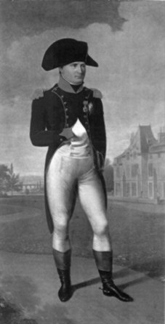

Pages:

Page 1: Beginning,
Napoleon Bonaparte,
Family
Page 2: Napoleon as emperor,
Napoleons last will,
Battles
Page 3: The Egypt battle,
The battle in waterloo
Page 4: Funny facts,
Sources

Beginning

Napoleon was a French emperor, and I will write the most important about him.
Here are some questions that I’m going to answer:
- Who was he?
- How did he get the power in France?
- How was France changed during Napoleons leadership?
- Why was Napoleon defeated and what happened to him after that?
- What happened in Europe after his defeat?
- What day is his birthday, how old should he be now?

Napoleon Bonaparte

He was born in the 15 of August 1769, 232 years ago, in the little village Ajaccio in Corsica. His real name was Napoleone Buonaparte, but he changed name in the age of 20. He was the one who completed the French revolution, and defeated almost whole Europe. In January May 1779 he was allowed to go in a military highschool in Paris. Five years later he became artillerist there. 1985, Charles Bonaparte dies, only 39 years old. 1 year after that he became an officer, and got holiday to travel and visit his mother in Corsica. He wasn’t fighting for France in the beginning, cause then he fought for Corsica. When Corsica was defeated in 1792, he became Captain for France. 1 year later he won a battle in Tulon, and became general. Then he won battle after battle, until the battle in Waterloo in 1815, when he died, and became one of the most famous persons in history.

Family
He had a father who was named Carlo Buonaparte, and he was a lawyer and farmer. His mother was called Letizia Ramolino, and he had 4 brothers and 3 sisters (!). He was born as the 4:rd child, the 2:nd surviving. The surviving kids were (sort by age):
Joseph, Napoleon, Lucien, Jèrôme, Louis, Caroline, Elisa and Pauline. He was married to the Italian Joséphine de Beauharnais, so he got control of the Italian armies. That made it easier for him to win battles. He had been together with 7 persons, Mademoiselle Georges, Pauline Foures, Giuseppina Grassini, Desiree Clary, Marie Waleska, Marie Louise of Austria and Joséphine de Beauharnais.
Napoleon as emperor

When he had won the battle in Italy, they had an election in France, who should be emperor. The result was Napoleon. He became emperor of France in the 2:nd of December 1804. He wanted to make sure that nothing unexpected should happen, so he put the crown on himself, even cause it was the pope who crowned him, so no one should be able to steal it. He also made his wife, Joséphine de Beauharnais, become empresses. After he had been crowned to emperor, he made the law “code civil”, who says that you own thing by yourself, and that everybody was equal against the law. He also started the Banque de France, who almost is like a bank is now, you left money and got a paper, then you could show the paper somewhere else and get the money.

Napoleons last will

In the 15:th of April 1812, he wrote his last will. It said this (rewritten text):
- I want to die in the roman religion, which I was born in more then 50 years ago.
- My ash should be a sign of the French people, who I have loved and taken care of.
- I want my dearest wife, Marie Louise, to make my son grow up in the best way.
- My son should always be remembered about that he is a French prince. He should never injure France or a Frenchman, and be proud.
- I will die early, poisoned by the Englishmen, cause they want to get their revenge.
- The two results of the invasions of France are characterized to the treason of Marmont, Augereau, Talleyrand, and La Fayette. I forgive them, and I want the French people to forgive them to.
- I thank my dear mother, and all my siblings for everything they have done for me.
- I excuse Louis for that he published some falsified documents in 1820.

Battles

He was great at strategies, so he won almost every battle. He almost took the whole south Europe. He lost three battles, one was when he tried to take over Israel, but failed. He also tried to take England, but had no success. And his last battle, the battle in waterloo. This is two important battles:

The Egypt battle
When he had won against Austria, he only had one enemy left, England. But he had already tried, and he couldn’t defeat England. So, to get England weaker, he attacked Egypt, cause England ruled in Egypt. In May 1798 he sailed away to Egypt, with 300 ships and 40000 soldiers. This was secret, cause napoleon didn’t want the Englishmen to know it, but in some way, the Englishmen did know it, so they waited a bit out from the seaport that they sailed from. But the Frenchmen succeed to avoid the English ships, and sailed to Egypt. When they had come to Egypt, they marched through the desert to the Nile. When he got there, he won an easy battle against their army, and France was ruling in Egypt. He started to translate the hieroglyphs, and thought that he had won an easy and good battle. But he was wrong. The English ships had come to Egypt, and destroyed all the France ships. After that, England was lord of the Middle Ocean, and Napoleon couldn’t get back to France. He tried to sail to France, cause now they had lost Italy, and he succeed, even though i was English ships on the whole ocean. When he came back, he had lost Italy and all the power of the sea, so the expedition was failed.

The battle in waterloo
The battle in waterloo was his last battle, and that battle made France fall apart. After he had lost the battle in Leipzig, he got weaker. French went smaller, and so his power. The 21:st of March 1814, his allied marched into Paris and forced him to let Ludwig the 18:th be emperor. Napoleon had to pay two millions franc every year, but he got an army with 1200 people, and an island, cause they didn’t want him to attack France, but he did. When he had been on his island, Elba, for 10 months, he went to land and attacked France. Ludwig sent an army with about 10000 people to kill Napoleon. When they met, the army joined Napoleon, and Ludwig escaped. Now Napoleon was emperor again. Now, he realized that he would not success with an army with just 120000 men, who were the French army, so he tried to make peace with his allied. But they didn’t trust him anymore, so the countries that were allied to Napoleon before agreed to help each other to destroy Napoleon. He realized that he shouldn’t survive if he didn’t attacked somewhere there he would split them. First he attacked the Persians, and he made them escape, and then he attacked the Englishmen, who had made a camp close to the city waterloo. He attacked again and again, but he couldn’t win, and not the Englishmen neither. But after some battles, the Persians came back, and together with England, they destroyed his armies. They put Napoleon on the island St: Helena, and guarded him day and night. He died the 5:th of May 1821,and a lot of peoples thought that the Englishmen had poisoned him. That’s the end of the story about Napoleon.

Funny facts
- It all started when he was at school and organized the snowball wars, so his team always won their wars. So his career started when he was young.
- There were 13 children in his family, but only 8 survivors.
- He was putted on an island, but escaped, so they poisoned him on the island next time.
- He was together with 7(!) women.
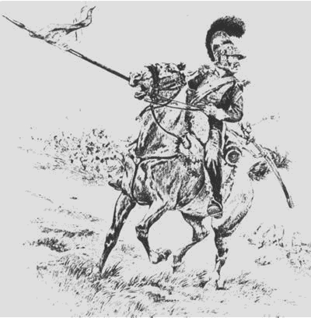
- He wrote love letters to them, and 9 of the letters have been found.

Source: http://stefa.se/matsa/fodd/sok.asp?sok=namn&ID=1751
http://home.swipnet.se/~w-92054/naph/naphist.htm
www.skola.umea.se/aktuellt/mariehemsskolan/stubben/millenn/page57.html
http://w1.490.telia.com/~u49006120/napoleon/index.html
www.napoleonguide.com
Bonniers stora lexikon
Nationalencyklopedin
Bra böckers lexikon

